Samples of the Dataset

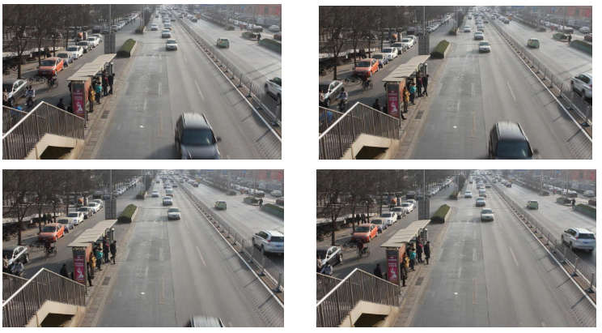

OUTPUT Sample:

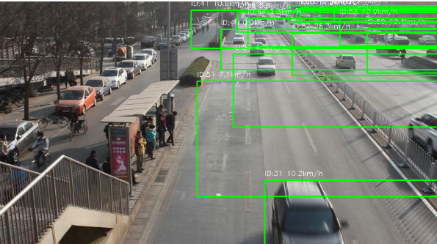

YOLOv8 Object detection

Speed estimation using DeepSORT

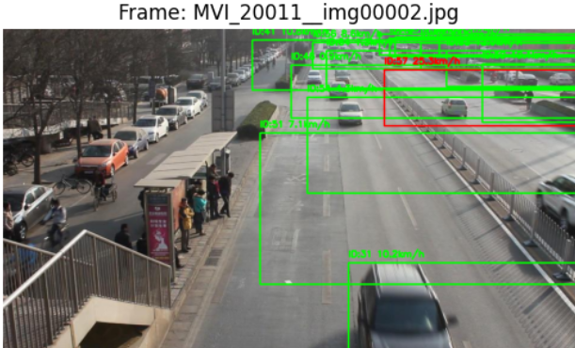

Enforcing speed limit

Accuracy:96.5%